Visible® Analyst
BPMN Tutorial

Visible Systems Corporation
24 School Street, 2nd floor
Boston, MA 02108
617-902-0767

www.visiblesystemscorp.com
https://twitter.com/VISIBLECorp

Email: contact@visiblesystemscorp.com



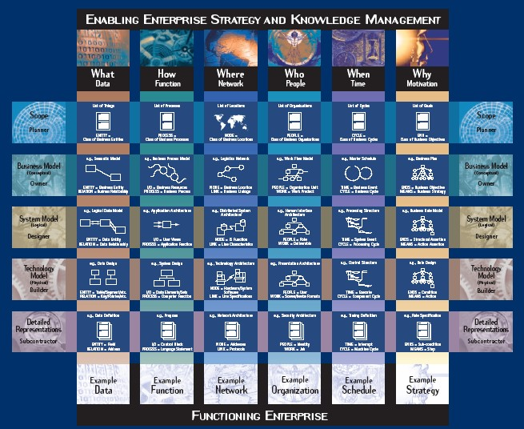
Enterprise-wide Analysis, Design and Planning for Improvement.

Information in this document is subject to change without notice and does not represent a commitment on the part of Visible Systems Corporation. The software described in this document is furnished under a license agreement or non-disclosure agreement. The software may be used or copied only in accordance with the terms of this agreement. It is against the law to copy the software onto any medium except as specifically allowed in the license or non- disclosure agreement.

No part of this manual may be reproduced or transmitted in any form or by any means, electronic or otherwise, including photocopying, reprinting, or recording, for any purpose without the express written permission of Visible Systems Corporation. Visible Systems Corporation makes no representations or warranties with respect to the contents or use of this manual, and specifically disclaims any express or implied warranties of merchantability or fitness for any particular purpose. Names, dates, and information used in examples in this manual are fictitious and only for examples.

Copyright 2008 – 2022 by Visible Systems Corporation, All rights reserved. Printed and bound in the United States of America.
This manual was prepared using Microsoft Word for Windows.

Visible Analyst
Tutorial on Structured Methods, Repository Management and The Zachman Framework Visible Analyst® is a registered trademark of Visible Systems Corporation.
The Zachman Framework illustration on the cover page of this tutorial was printed and used with the permission of the Intervista Institute © 2004 (www.intervista-institute.com). Microsoft and Windows are registered trademarks of Microsoft Corporation. Other product and company names are either trademarks or registered trademarks of their respective owners.

Dear Colleagues:

Thank you for your time in selecting our product, the Visible Analyst. At Visible, we take your time and effort seriously. To that end, we pride ourselves on delivering the most appropriate, value-oriented solutions. And, we feel that we offer the very best in product support that often differentiates us from our competitors.
As you read though the tutorial, please take the time to understand that our approach to software development is one of a model driven approach. Within the framework of this approach, Visible, in part, supports the Model Driven Architecture (MDA) as defined by the Object Management Group (OMG). This group, commonly referred to as the OMG, is an open membership, not-for-profit consortium that produces and maintains computer industry specifications for interoperable enterprise wide applications. For more information about the OMG and in particular their MDA specification, please reference their web site at http://www.omg.org/mda/.

In conjunction with a model driven approach, Visible has incorporated a framework to enable you to better plan and manage your Enterprise Architecture effort. In this edition, The Zachman Framework, is the framework of choice. However, you can customize the Visible Analyst to implement other frameworks like, for example, the US Federal Enterprise Architecture Framework (FEAF).

Visible Systems Corporation. Visible Analyst, Visible Developer, Visible Data Governance, Visible Web Portal, Visible Self Service Data Discovery, Visible Sight (Context-driven business insights), Razor SCM, Polaris (Task Management).

and the online help system (accessed by pressing F1).

The Zachman Framework

INTRODUCTION
It has been Visible Systems Corporation’s experience that no matter where you start in your application development activities, you will soon find yourself making certain ―assumptions‖ about things not under your control or outside of your scope. To confirm or validate these assumptions, you find yourself addressing the artifacts up and down the Zachman Framework rows and/or across the columns to capture the true drivers for the system: who? what? where? when? why? and how?1 This means coordinating with the affected or interested business experts, system users, and management.

In 1987 John Zachman wrote, ―To keep the business from disintegrating, the concept of an information systems architecture is becoming less of an option and more of a necessity.2‖ From that assertion over a decade ago, the Zachman Framework for Enterprise Architecture has evolved and become the model around which major organizations view and communicate their enterprise information infrastructure. The Zachman Framework draws upon the discipline of classical architecture to establish a common vocabulary and set perspectives--a framework--for defining and describing today‘s complex enterprise systems. Enterprise Architecture provides the blueprint--or architecture--for the organization‘s information infrastructure and provides a framework for managing information complexity and managing change.

Today the Zachman Framework has become a standard for Enterprise Architecture used by many of the most successful organizations in the world. Evidence of the acceptance of the Framework has been apparent at the annual forums conducted by the Zachman Institute for Framework Advancement (ZIFA, www.zifa.com). At each forum, attendees hear presentations on the many different aspects and practical uses of the Framework. Visible fully supports both the concept and philosophy of the Zachman Framework. Visible helps clients gain greater control of their information systems and technology requirements through development of an enterprise-wide architecture.

1 ―Visible and the Zachman Framework for Enterprise Architecture‖ by Alan Perkins p. 2. Copyright © 1997-2001, Visible Systems Corporation.
2 ―A framework for information system architecture‖ by J.A. Zachman p. 454 IBM Systems Journal, Vol. 26, Nos. 3,
1987, ©1987, 1999 IBM.

Visible takes an engineering approach to developing an enterprise architecture. We use a combination of forward and reverse engineering to establish the enterprise architecture. Forward engineering tasks include business planning and data and process modeling. Reverse engineering tasks include analysis and documentation of all existing structures for the organization. The result is a model that represents an integrated view of the enterprise architecture framework, with redundancies and discrepancies resolved and documented. All conceptual and logical architecture components can all be maintained in Visible‘s proprietary modeling tool, Visible Analyst®.

The Visible Analyst supports the tasks and techniques involved in the creation and management of an enterprise architecture, with sufficient flexibility to integrate and support other approaches to software engineering. Visible Analyst captures business plans of multiple organization levels and maintains the hierarchy of planning components (mission, goals, strategies, measures, business rules, etc.).

Unlike many other modeling tools, Visible Analyst has the capability of directly linking each business plan component to the entities and attributes of a data model that support/implement the planning elements. This feature is used to control quality and completeness, and to ensure that process and system designs meet business requirements. Visible Analyst can also be used to specify physical information system designs based on the data model or import physical designs of existing data structures into the repository, and then link them back to the business plan component.

The following sections provide an overview of the Visible Analyst‘s repository and modeling capabilities, followed by an explanation of the Visible Analyst framework project. Each cell in the Zachman framework project is detailed in a cell-by-cell review including an explanation of the artifacts created for the cell in the Visible Analyst. A backup copy of the Zachman project is located in the VA\Zachman folder on the product CD. If you do not have a product CD, contact Visible Systems support at support@visiblesystemscorp.com for a copy of the document and backup file set. To access the project, see the Restore instructions at the beginning of this tutorial.

It is important to remember that the Visible Analyst Enterprise Project using the Zachman Framework is not a static one-time snapshot view of the enterprise. As mentioned in the cell explanations, the artifacts such as the business plan, physical data model, security architecture, strategic goals, etc. will change as the enterprise changes. Using the Visible Analyst and its repository to model the enterprise provides a one-stop location where all information about the enterprise is located. External documents may be changed, but the hyperlinks to the artifacts are maintained within the enterprise project, allowing for both a birds eye and physical implementation perspective of the enterprise.

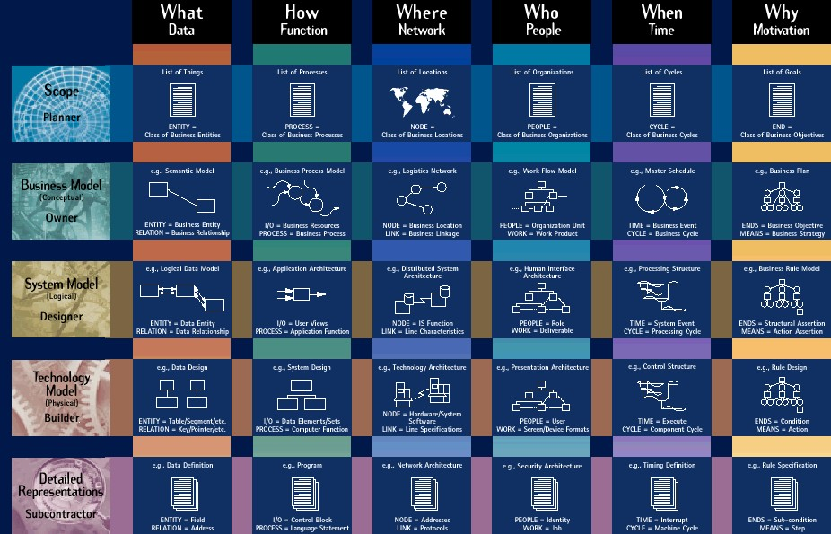

Figure 2-1 Zachman Framework

Image provided courtesy of the Intervista Institute, Copyright © Intervista Institute (www.intervist-institute.com)

Business Planning Techniques

INTRODUCTION
Business rules are used to capture and implement precise business logic in processes, procedures, and systems (manual or automated). They can also provide the basis for expert systems. One way these business rules are captured in the Visible Analyst is through the creation of Strategic Planning statements, as well as the triggers, check constraints, and element definitions as explained below.

Enterprises that take a model driven approach to software component development can use business rules to refine the models and create better designs. An enterprise that properly documents its business rules can also manage change better than one that ignores its rules. Business rules may be any of the following:

- Definitions of business terms
- Data integrity constraints
- Mathematical and functional derivations
- Logical inferences
- Processing sequences
- Relationships among facts about the business

These types of business rules are examples of metadata. They can be defined as metadata, modeled as metadata, and, most importantly, they can be implemented as metadata for an enterprise's operational and strategic information management systems.

Implementing business rules as metadata is the most rigorous and, at the same time, most flexible approach to business rule implementation. This is in contrast to other implementation approaches.

- Process-driven approaches can be rigorous, but they are by no means flexible. In any process-centric approach, implementing the business rules is fairly straightforward, but, because they are typically implemented in code, changing them can be difficult and labor intensive.

  - Procedure-driven approaches, characterized by manuals and checklists, are certainly flexible, but they are not rigorous. Procedures can be changed very easily. However, procedures are only as rigorous as their users choose them to be. People can and will ignore procedures.

VISIBLE BUSINESS RULES

Visible has pioneered a method and tools that allow business rules to be defined and implemented as metadata. Our approach captures rules as logical model elements and implements them as database tables, triggers, and object actions. The key to this is fully understanding the rules, documenting them consistently, and building conceptual information models and logical data models that accurately reflect the rules. Visible’s flagship modeling tool, Visible Analyst®, has the ability to store business rules in many formats in a single enterprise architecture model. This makes the rules visible. The rules can be modeled, including specific values for metadata. These migrate automatically to any database design generated from the models and, ultimately, are automatically inserted into the database tables when they are created or altered from the design.

This means that a business rule can be documented once in a logical model and still be part of multiple system designs and implemented databases. This one-logical, many-physical representation of business rules as metadata also allows a significant change in software component design. Components can be designed to access database tables for rules and do not have to include complex decision tables and rule-based processing logic.

There are several advantages that an enterprise can realize from using business rules as metadata:

  - Allows maximum flexibility
  - Reduces system maintenance
  - Simplifies system design, development and implementation
  - Rules can change without affecting implementation
  - Ensures that systems fully support business needs
  - MIS personnel don't need to learn the intricacies of the business

BUSINESS RULES IN BUSINESS MODELS
Business rules take several forms when documented in enterprise business models. There is one best representation that is appropriate for each particular type of business rule. For example, strategic business rules are best modeled as simple business statements, while operational business rules are best modeled as static data instances and derivations.

Business Statements
A business statement is a simple declaration. Business statements should be written in business language. They should be concise and clear. They should represent a single concept or idea. They should state business requirements, not system requirements. The kinds of strategic business rules that can be modeled using business statements are illustrated in Figure 3-1.
Enterprise Mission

Critical Success Factors
Critical Success Factors
Enterprise Mission

Events
Events

Critical Decision Set
Critical Decision Set

Goals
Goals

Strategies
Strategies

Value-Based Process
Value-Based Process

Objectives
Objectives

Critical Assumption Set
Critical Assumption Set

Business Rules
Business Rules

Performance Measure
Performance Measure

Information Needs
Information Needs

Functions
Functions

Figure 3-1 Business Rules

The Visible Analyst captures these business rules as Strategic Planning statements, which can be defined in the statement hierarchy then linked to other repository entries. This linkage provides both a validation of the rule as implemented by the object, such as a process, entity, element, check constraint, trigger, etc, and a graphical representation of the rules for communicating the business vision and rules that govern the organization. The hyperlink capability, available for any editable field in the Visible Analyst, can also be used to reference and link to external documents, web sites, applications, etc.

The next section explains the strategic planning capabilities within the Visible Analyst.

Tutorial Business Process Diagramming with BPMN

OVERVIEW
Visible Analyst provides support for Business Process Modeling Notation (BPMN) diagrams based on the Business Process Modeling Initiative developed by the Object Management Group (OMG). The complete specification is available for download from the OMG website, www.omg.org.

The primary goal of BPMN is to provide a modeling notation is an effective communication medium across all the constituencies in computing technology supported organizations.
BPMN is specifically designed to communicate process behavior information in a manner easily understood by business end users while providing supporting technology organizations with sufficient information about process execution, flow and dependencies to understand the workings of the business processes being modeled. BPMN notation is designed therefore to support the needs of not only business end users but also the business analysts who develop models and technical analysts who implement the model processes.

Future releases of the Visible Analyst Workbench are planned that will use defined BPMN models to generate execution languages such as BPEL4WS (Business Process Execution Language for Web Services).

BPMN models describe business process behavior and as a result use an event based paradigm. Both parallel and conditional behavior is supported in the modeling notation and also in the Visible Analyst‘s implementation of BPMN. A number of symbols are used to describe process flows, events and decisions and allow the viewer to easily differentiate between sections of the BPMN diagram.

BPMN MODEL TYPES
There are three types of sub-models that may be used within an end-to-end BPMN model: Functional Private (internal) business processes - Private business processes internal to an organization, such as the Sales Department. If swimlanes (described below) are used, then a private business process will be contained within a single pool, with all Sequence Flows contained within the Pool and no Message Flows crossing the boundaries of the Pool.

Abstract (public) processes - These processes represent the interactions between a private business process and another process or participant. Only those activities that are used to communicate outside the private business process, plus the appropriate flow control mechanisms are included in the abstract process. The ―internal‖ activities of the private business process are not shown in the abstract process. Thus, the abstract process shows to the outside world the sequence of messages that are required to interact with that business process. An example of this would be the interaction between the Customer and the company‘s Sales Department.

Collaboration (global) processes - A collaboration process depicts the interactions between two or more business entities, and is defined as a sequence of activities that represent the message exchange patterns between the entities involved. A collaboration process can be shown as two or more abstract processes communicating with each other. The interaction of the company‘s Accounting Department and Sales Department and the processes performed by both to complete the sales cycle is an example of a collaboration process.

DEFINITIONS
BPMN diagrams are drawn using four basic categories of objects: Flow Objects, Connecting Objects, Pools/Swimlanes, and Artifacts

Flow Objects
Flow Objects are the main graphical elements of the diagram and consist of Event, Activity (process) and Gateway symbols.

Event An event is something that occurs during the course of a business process which affects the flow of the process.. There are three types of events: Start Events, Intermediate Events and End Events. Each Event type has a ―trigger‖, i.e., a determination for the cause of the event. Each event trigger has a unique appearance to indicate the trigger type, as shown in Figure 16-2.

Activity An activity (process) is a generic term that represents the work that a company or organization performs. Activities can be atomic or non-atomic (compound) and are represented as a rounded rectangle. Activity types include Process, Sub-Process (which can be defined as a Transaction), and Task.

Atomic Task Activity

Figure 16-1 Activity

Start Event Intermediate Event End
Event

Message

Timer

Error

Cancel

Compensation

Rule

Link

Multiple

Terminate

Figure 16-2 Event Types

Gateway A Gateway is used to control the divergence and convergence of multiple Sequence Flows. It will determine branching, forking, merging, and joining of paths.

The Gateway, sometimes called a ―fork in the road‖, is used to indicate Decisions, where the Sequence Flow can take two or more alternative paths. For a given performance (or instance) only one of the paths can be taken. A Decision is not an activity from the

business perspective, but is a type of Gateway that controls the Sequence Flow between activities. It can be thought of as a question that is asked at that point in the process, and the question has a defined set of alternative answers (Gates). Each Decision Gate is associated with a condition expression found within an outgoing Sequence Flow. The conditions are evaluated in a specific order and first condition that evaluates to ―True‖ determines the Sequence Flow that will be taken. One of the Gates may be marked as ―default‖, and is the last Gate considered.
Choosing a particular Gate chooses the corresponding Sequence Flow.

Exclusive Gateway (XOR) An Exclusive Decision (Gateway XOR) has two or more outgoing sequences, but only one of them may be taken. The conditions are evaluated in a specific order and first condition that evaluates to
―True‖ determines the Sequence Flow that will be taken. One of the Gates may be marked as ―default‖, and is the last Gate considered. Exclusive Gateways can be used as a merge, for alternative Sequence Flow, though rarely used in this way. There are two types of Exclusive Decisions: Data-Based and Event- Based.

Inclusive Gateway (OR) The Inclusive Gateway OR can be used to model Inclusive
Decisions or it can be used as a Merge. An Inclusive Decision Gateway symbol has a Bolded circle within the diamond Gateway symbol.

When used to model Inclusive Decisions, each of the Sequence Flows (at least two) would be attached to the Gates of the Gateway. The Condition Type of the Sequence Flow is set to Expression, and the modeler would add the expression to be evaluated in the Condition Expression field of the flow. A default Sequence Flow may be used.

When the Inclusive Gateway is used as a Merge, it will wait for (synchronize) all Tokens that have been produced upstream. It does not require that all incoming Sequence flow produce a Token, (as the Parallel Gateway does). It requires that all Sequence Flow that were actually produced by an upstream (by an Inclusive OR situation, for example). If an upstream Inclusive OR produces two out of a possible three Tokens, then the downstream Inclusive OR will synchronize those two Tokens and not wait for another Token, even though there are three incoming Sequence flows.

Complex Gateway Complex Gateways are included to handle situations that are not easily handled through the other types of Gateways. Complex Gateways can also be used to combine a set of linked simple Gateways into a single, more compact situation. Modelers can provide complex expressions that determine the merging/splitting behavior of the Gateway. The symbol for a Complex Gateway contains the asterisk symbol within the Gateway diamond symbol.

When the Gateway is used as a Decision, then the expression determines which of the outgoing Sequence Flow will be chosen for the Process to continue. The expression may refer to process data and the status of the incoming Sequence Flow. For example, the expression may evaluate the Process data and then select different sets of outgoing Sequence Flow, based on the results of the evaluation. The expression should be designed so that at least one of the outgoing Sequence Flows will be chosen.

When the Gateway is used as a Merge, then there will be an expression that will determine which of the incoming Sequence Flow will be chosen for the Process to continue. The expression may refer to process data and the status of the incoming Sequence Flow. For example, the expression may specify that any 3 out of 5 incoming Tokens will continue the Process. Another example would be an expression that specifies that a Token is required from Sequence Flow ―a‖, and that a Token from either Sequence Flow
―b‖ or ―c‖ is acceptable. The expression should be designed so that the Process is not stalled at that location.

.

Gateway Control Types | Appearance
Data-Based Exclusive Decision (XOR)
Event-Based
Exclusive Decision (XOR)
Inclusive Decision / Merge (OR)
Complex Decision / Merge
Parallel Fork / Join (AND)

Figure 16-3 Gateway Types

Connecting Objects
Flow Objects are connected on the diagram using Sequence Flows, Message Flows and Associations.

Sequence Flow A Sequence Flow is a solid graphical line that is used to show the order that the activities will be performed in a Process. Each flow has only one source and one target.

Normal Sequence Flow

Figure 16-4 Sequence Flow

Additional sequence flow sub-types may represent certain conditions, such as a Conditional flow, Default flow, Exceptions flow etc.

Conditional Flow A Sequence Flow can have condition expressions that are
evaluated at runtime to determine whether or not the flow will be

used. If the conditional flow is outgoing from an activity, then the sequence flow will have a mini-diamond at the beginning of the line.

Conditional Flow

Figure 16-5 Conditional Flow

Default Flow For Data-Based Exclusive Decisions or Inclusive Decisions, one type of flow is the Default condition flow. This flow will be used only if all of the other outgoing condition flows are not true at runtime. The Default Sequence Flow will have a diagonal slash at the beginning of the line.

Default Flow

Figure 16-6 Default Flow

Exception Flow An Exceptions Flow occurs outside the Normal Flow of the
Process and it is based upon an Intermediate Event that occurs during the performance of the Process. The Exception Flow begins at the Error Intermediate or End Event attached to the boundary of the activity, signifying an interruption in the activity.

Exception Flow

Figure 16-7 Exception Flow

Compensation Flow A Compensation Flow defines the set of activities that are
performed during the rollback of a transaction to compensate for the activities that were performed during the normal flow of the process. Compensation can also be called from a Compensate End or Intermediate Event

Compensation Association

Figure 16-8 Compensation Flow

Message Flow A Message Flow is drawn using a dashed line with a small circle at the beginning of the line. This line type is used to show the flow of messages between two entities that are prepared to send and receive them. In BPMN, two separate Pools on the diagram will represent the two entities

Message Flow

Figure 16-9 Message Flow

Association An Association Flow is used to connect one or more Data Objects (Artifacts) to an activity, and to show that the Data Object is either an input or output to the Activity.

Association Line

Figure 16-10 Association

Pools and Lanes
BPMN models utilize two important conceptual modeling devices to distinguish process flow characteristics, pools and lanes.

Pool A Pool (defined as a System Boundary entry type in the repository) represents a participant in a process, and it also acts as a "swimlane" and graphical container for portioning a set of activities from other pools.

When a Pool is added to a diagram, only the name of the Pool is displayed. The swimlane labels will be displayed once a BPMN item is moved within the pool boundary. If the orientation of the Pool symbol is vertical, the name of the Pool and lanes are displayed at the top of the Pool, otherwise the labels are drawn on the left-hand side of the pool. Pools whose width is greater than their height are vertical. To change the orientation of the Pool, highlight the pool symbol, select one of the ―handles‖ (the green boxes surrounding the Pool symbol) a drag the handle to a new location on the diagram, expanding the Pool symbol. You can also right mouse click on the Pool symbol and choose the Stylize option to modify the size and orientation of the Pool.

The Attributes field on the Define Item tab in the repository will display the items contained within the Pool and its lanes.

Lane A Lane is a sub-partition within a Pool and will extend the entire length of the Pool, either horizontally or vertically. Lanes are used to categorize the activities in the Pool. If there is only one lane, then the lane shares the name of the Pool. While BPMN does not specify the usage of the Lanes, they are often used to identify internal roles (Manager, Associate), systems (enterprise application) and internal departments (shipping, finance sales). See Figure 16-11.

Up to 4 Lane names can be assigned for each Pool.

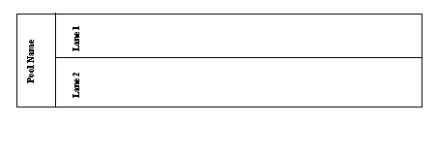Figure 16-11 Pool and Lanes

Artifacts
Artifacts are used to provide additional information about the Process, and are represented by a Data Object, a Group, and an Annotation.

Data Object A Data Object is represented by a square symbol with the top right corner of the symbol turned down. Artifacts are used to provide information about the process or elements defined or produced within the process, but do not affect the process. Data Objects are connected to other BPMN symbols by an Association Flow.

Data Object

Figure 16-12 Data Object

Group A Group is a visual representation around a number of activities. Groups are represented in the Visible Analyst through the use of symbol coloring, or the user can draw a flow around the diagram objects to represent a group.

Annotation An Annotation (referred to and implemented as a Note symbol in the Visible Analyst) is a Text Annotation, used as a mechanism for the modeler to provide additional information for the reader of a BPMN diagram. A Note object (and a Note Link) in the Visible Analyst does not maintain a repository entry; all information is written on the diagram as the Note label. Notes are connected to a specific object on the diagram with a Note Link line, but neither the Note nor the Note Link line affect the flow of the Process.

Note Symbol

Figure 16-12 Data Object

BUSINESS PROCESS DIAGRAM ATTRIBUTES
A number of attributes are associated with BPMN Diagrams. Some of these attributes include, Diagram Id, Name, Version, Author, Language (for code generation), Creation Date, Modification Date, etc. Use the Boilerplate and Boilerplate Keywords feature in the Visible Analyst to display these attributes on a BPMN diagram. See Boilerplates and Boilerplate Keywords.

Note
 Boilerplates and Boilerplate keywords are not available in the Educational version of Visible Analyst.

DEVELOPING BPMN DIAGRAMS
As described by the OMG group (www.omg.org.) in their Business Process Modeling Notation specification, there are three basic BPMN models:

    - Private (internal) business processes
    - Abstract (public) processes
    - Collaboration (global) processes.

Each of these types may contain Pools and Lanes, but are optional based on the process type being modeled. In this tutorial you will create a Collaboration process describing the Road Test processes to demonstrate the many features of BPMN diagramming. The Participants will be the DMV Evaluator and the License Applicant.

Designate the Starting Event
The event type will be a Timer event, indicating the scheduled appointment time for the Road Test. The Road Test will be the Business Process modeled by the BPMN diagram.

Set the Zoom Level: | 1 | From the View menu, select 66% zoom so that you can see all of the needed workspace.
Create a New Diagram: | 2 | From the File menu, select New Diagram.
 | 3 | Select the diagram type Business Process Model.
 | 4 | Select Standard Workspace and Landscape as the Orientation.
 | 5 | Click OK.
Add a Start Event: | 6 | Click the fifth symbol button, the open circle, on the control bar. This is the Start event.
 | 7 | Place the cursor in the upper left corner of the workspace, and click the left mouse button. The starting event is drawn on the diagram.
Name the Event: | 8 | Label the event ―Scheduled Driver Test‖.
Select the Event type: |  | Select ―Timer‖ in the Trigger field and click OK.
Save the Diagram: |  | Save the BPMN diagram with the label  ―Driver Test BPMN Diagram‖.

Add a Process Symbol to the Diagram
A Process is an activity performed within a company or organization. The Process symbol is a rounded rectangle, the first symbol in the symbol bar.

Add a Process symbol: | 1 | Click the first symbol button, the rounded rectangle, on the control bar.
 | 2 | Place the cursor to the right of the start event and click the left mouse button. A process symbol is drawn.
Label the Process: | 3 | Label the process ―Validate Applicant‖.
Add other Processes: | 4 | Add the other processes ―Perform Road Test‖ and ―Issue License‖ to the right of Validate Applicant as shown in Figure 16-13.
Save the Diagram: | 5 | Save the BPMN diagram.

Scheduled Driver Test Validate Applicant PerformRoad Test Issue License

Figure 16-13 Flow Object Layout

Adding a Pool to the Diagram
A Pool represents a Participant in a Process, and it also acts as a graphical container for portioning a set of activities from other pools. In our example, we can identify two DMV departments that would be responsible for the processes in our diagram. The ―Applicant Testing‖ department would perform the actual tests and evaluate the test results. The ―DMV Administration Staff‖ would perform the other duties such as accepting applications, validating applicants, issuing licenses to qualified applicants, etc.

Add a Pool: | 1 | Click the seventh symbol button, the rectangle, on the control bar. This is the Pool object.
 | 2 | Place the cursor above the ―Perform Road Test‖ process and click the left mouse button. A Pool symbol is drawn. Label the Pool ―Applicant Testing‖.

3 Click the control bar arrow to activate the select mode.

 | 4 | Select the pool you just drew and
 |  | expand its size by a clicking and
 |  | dragging at its ends. Make sure the
 |  | activities that are the Applicant Testing
 |  | department‘s responsibility fall within
Save the Diagram: | 5 | this pool as shown in Figure 16-14. Save the activity diagram.

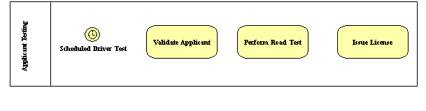Figure 16-14 Flow Objects within a Pool

Adding Sequence Flows to the Diagram
Sequence flows are directional lines that communicate the order in which the processes are to be performed. They can be labeled or left unlabeled with a default name of ―«unnamed»‖.
For clarity, we suggest that you label the sequence flows.

Add a Sequence Flow: | 1 | Click the horizontal arrow symbol button on the control bar, labeled Sequence Flow.
 | 2 | Place your cursor on the start event. Left-click the mouse and hold down the button as you drag the cursor to the right until it is within the first process symbol and let go of the mouse button.
Label the Sequence Flow: | 3 | Label the sequence flow ―Test

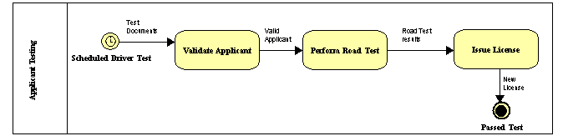

Documents‖.
Add an End event: | 4 | Click on End event circle, the third circle in the list. Add the End Event under the process ―Issue License‖ and label the event ―Passed Test‖.  Select ―Terminate‖ in Result field by clicking the down arrow.
 | 5 | Add the rest of the sequence flows as shown in the Figure 16-15.
Save the Diagram: | 6 | Save the BPMN diagram.

Figure 16-15 Sequence Flows Added

As designed, this example represents a Private internal process with the Application Testing department of the DMV. However, it is also important that you understand how Collaborative Business Processes interact. We will add another set of processes within a Pool to show the interaction of the Application Testing department and the Licensing Department. Included is a Gateway to display the decision making capability of the BPMN diagrams.

Add a Start Event: | 1 | Click the fifth symbol button, the open circle, on the control bar. This is the start event. Add the Start event ―Vehicle Road Test‖ of type ―Timer‖ below the current Pool, as shown in Figure 16-16
Add a Process symbol: | 2 | Click the first symbol button, the rounded rectangle, on the control bar. Add the processes as shown in Figure 16-16.
Add a Gateway: | 3 | Click the second symbol button, the diamond, and place your cursor to the

right of the process ―Test Results. Left mouse click to draw the gateway, labeled as ―Pass or Fail‖.

For the gateway type, choose ―Data- Based Exclusive Decision‖.
Add Sequence flow to Gateway: | 4 | Draw the sequence flow from the gateway to the process ―Reschedule Road Test‖. Because the gateway is a data- based decision, enter the following expression into the Expression field:  ―Test result=F‖.  Add a second sequence flow from the gateway to the process ―Issue New License, and enter this expression into the Expression field  ―Test result=P‖.
Add a Stop Event: | 5 | Click on the last circle icon, the Stop Event, and add it between the processes  ―Reschedule Road Test‖ and ―Issue New License‖. Label the event ―End of Test‖ and choose ―Terminate‖ as the end Event Result type.
Add Sequence Flows to the Diagram: | 6 | Add the rest of the sequence flows as shown in Figure 16-16.
Add a second Pool: | 7 | Click on the Pool icon, add it to the diagram and label the pool ―Licensing Department‖. Click the ESC key on the keyboard to exit drawing mode.
 | 8 | Select the pool you just drew and expand its size by a clicking and dragging at its ends. Make sure all of the new symbols are within the pool boundaries.
Save the Diagram: | 9 | Save the BPMN diagram.

Notes
 The labels of the Gateway, Sequence Flows and Events can be moved on the diagram. Left mouse click on the label name, hold down the mouse button, and drag the label to the new position on the diagram.

 To invert the direction of the sequence flow drawn between the ―Pass or Fail‖ gateway and the process ―Issue New License‖, right mouse click when drawing the line to invert the line direction.

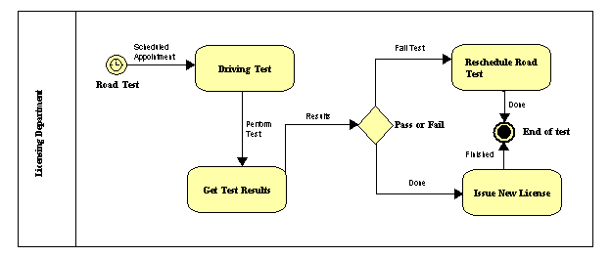Figure 16-16 Second Pool

Message flows are used to show the flow of messages between two entities that are prepared to send and receive them. In BPMN, two separate Pools on the diagram will represent the two entities.

Add a Message Flow: | 1 | Click the second line type, Message flow  , and draw the flow between the processes  ―Validate Applicant‖ and ―Driving Test‖ as shown in Figure 16-17.
Save the diagram: | 2 | Save the BPMN diagram.

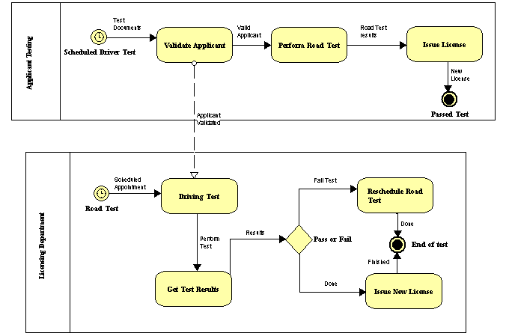Figure 16-17 Message Flow Between Pools

Working with the Repository Functions

OVERVIEW
This unit helps familiarize you with the operation of the Visible Analyst repository and shows you the power of an online, interactive database for systems analysis, design and data modeling. The TEST project used in the previous lessons is used as the basis for your exercises.

The repository is a powerful tool for creating and managing the narrative portions of a system‘s specification. A project repository is used to provide an entry location for all project documentation. Each graphical entry on your diagrams has an automatically created corresponding entry in the project repository, as do any items entered into a Composition or Alias field.

You have the ability to thoroughly define all of your graphical entries in the repository or to simply enter notes about them in the Notes field. As an integrated part of Visible Analyst, the repository operates in parallel with the diagramming functions to accomplish data decomposition logically. It contains powerful data management, text editing, import/export, and report facilities. By using it, meaning can be ascribed to diagrams and an asset of ever- increasing value can be created. After defining items, changing entries and entering notes, you can generate reports from this information in many different forms.

When you finish defining your data and processing, the repository also allows you to put it into an ASCII file and export it. The ASCII file can then be sorted to move data specifications to your database and process specifications to your text editor for writing code. (The Shell Code Generation utility can also be used for this purpose.)

Note
 Users of the Educational and Demonstration versions of Visible Analyst cannot add items directly into the repository. First add the object to the diagram, and then edit it into the repository.

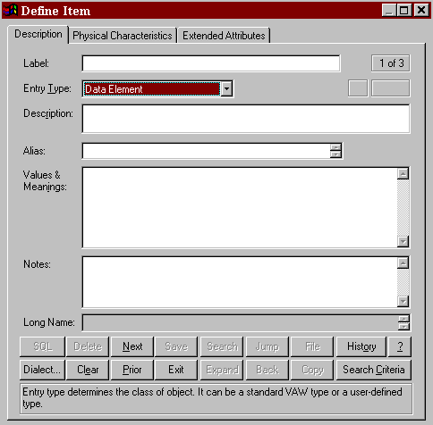Figure 17-1 Blank Repository Dialog Box, Page One

REPOSITORY BASICS

Repository Control Buttons
The repository control buttons (see Figure 17-2) are always displayed at the bottom of the repository dialog box. Each of the button functions is accessed by clicking on the button or, as is customary in Windows, by using its keyboard shortcut by holding down the ALT key and pressing the underlined letter to execute the button function. Only the functions available to you at a given time are active; the others are grayed. The button functions are:

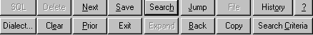Figure 17-2 Repository Dialog Box Control Buttons

SQL This button opens the Generated SQL for View dialog box. This dialog box displays the SQL generated for the current view object based on the view table and column specifications selected when creating the view, as well as the current SQL dialect. This button is active only when the entry type is View.

Dialect This activates the RDBMS SQL Dialect dialog box. From there, you can change the current SQL dialect.

Delete This deletes the current repository entry from the database. An entry can only be deleted when it has no location references, meaning that it does not appear on a diagram nor as an attribute of another repository item.

Clear This clears the display of an entry and displays a blank repository dialog box. This allows you to Search for an existing entry or add a new entry. If you have made changes, you are prompted to save them before clearing. Your current location in the repository remains unchanged.

Next This displays the next sequential repository entry that meets the repository search criteria (see below).

Prior This displays the previous sequential repository entry that meets the repository search criteria.

Save This saves all changes made to an entry.

Exit This or the ESC key exits from the repository.

Search This initiates a search for a particular entry in the repository.
The procedure is explained in the section on Search Capabilities.

Expand This allows you to expand or contract the display size of some
Contract fields. The fields that normally display four lines can expand to display 15.

Jump This allows you to jump immediately to another entry that is referred to in the current one. This feature is described in the section on Navigation Capabilities.

Back This button provides a means of jumping to the previous repository entry. You can then continue to move backwards displaying previous repository entries.

File This allows you to insert text from a DOS file at the cursor position or to copy highlighted text to a DOS file. It is explained in further detail in the Visible Analyst Operation Manual and in the online help system.

Copy This button provides a means of copying the current object.

History This provides a means of jumping back to a previously displayed repository object. A list is kept of every object definition that has been displayed. If you choose this button, the History dialog box appears and you can jump between entries by double-clicking on an entry. The maximum is 500 objects.

Help(?) This displays context sensitive help about the repository. You can also press F1 to activate the help system.

Search Criteria This allows you to specify how the repository is to be searched.
It is explained in the section on Search Capabilities.

Other buttons that may be displayed on the Define dialog box are:

Primary Key If the current object being examined is an entity type, the primary key button is displayed to the left of the Composition/Attributes field.

Attributes Details This button provides a means of populating the composition of a repository entry with components and physical information. This button is displayed to the left of the Composition/Attributes field.

When the Entry Type is a Class, or when the Classic User Interface is turned off, the Add button displayed beneath the Attributes Details button is active. You can use this button to add details.
When you begin typing in the field next to the Add button, the

button is enabled. Click the Add button to add the attributes to the Attributes field.

Editing Keys
Because the Edit menu is not accessible from the repository, you can use the right-click menu that is available when an object (text) is highlighted and you click the right mouse button.
Using the right-click menu, you can Cut, Copy, Paste, or Delete the selected object.

Field Types
The data repository of a Visible Analyst project is displayed using Define dialog box variations corresponding to different diagram objects. You see and work with some of these variations during the course of this lesson. The basic dialog box, shown in Figure 17-1, is for data elements, aliases, miscellaneous objects and external entities or source/sinks. Other objects, such as data stores, processes, functions, entities, relationships, modules, data flows information clusters, etc., have variations in individual fields and tabs of the Repository dialog box to accommodate the specific needs of those items. Some of these differences are seen later in the lesson.

Label Field
This is the name of the repository item. The names of items drawn on diagrams are automatically entered here.

Entry Type Field
This tells Visible Analyst what kind of object the item is: process, data flow, entity, etc. The entry type can be entered manually, or you can select the type from the scroll box accessed by clicking the down arrow at the end of the entry type field.

Note
 You can edit the Entry Type and Label fields of data elements and data structures that do not appear on diagrams. The entry type for a data element cannot be changed if physical information for that element has been entered.

Description Field
The Description field is a two-line field that provides a convenient place to enter a somewhat more extensive descriptive title of the object than the Label field allows. The contents of this field are used for the Comment on Column (data elements) and Comment on Table (entities) when SQL DDL is generated if the selected SQL dialect supports this syntax.

Alias Field
The Alias field contains 10 lines of 128 characters each. It allows for the entry of alternative labels to the one used as the object label. This is most commonly used for indicating the cryptic abbreviations that are sometimes used in the actual coding of a software program, as opposed to the plain English names that are desirable for reference. The Alias field is an intelligent field. Data names entered into it establish new repository entries for these aliases.

Attributes Field
The purpose of the Attributes field is to accumulate the collection of data elements that you wish to define as constituting a data flow, entity, data store, etc. The Attributes field is an intelligent field. Data names entered into it establish new data element repository entries or update existing ones. These new data elements can then be used for further definition. Data flows, data structures and couples can also appear in some Attributes fields.

When you click the Attributes Details button, the Add Attributes dialog box appears. Using this dialog box, you can define up to 12 components and some of their properties. As you enter items, the dialog box automatically scrolls as necessary to allow you to enter more items until you reach 12. When you complete the entries, click OK to add them to the Attributes field. If you need to add more than 12 components, click the Attributes Details button again; and a new dialog box opens so that you can add additional attributes.

Use the Add button at the bottom of the Attributes field to add components one at a time. When you begin typing in the field next to it, the Add button becomes active. Complete your entry, and then click Add to enter the component in the Attributes field.

Values & Meanings Field
The Values & Meanings field allows an unlimited number of lines. The maximum number of characters that can be contained in the field is 64K. This field allows the entry of specific information about the value(s) the item can take.

Discriminator Values & Meanings Field
If the current object is a data element that is used as a discriminator, this field contains a list of values to identify the subtype entities. For each subtype, a value can be entered that will uniquely identify it. By default, these values are numbers starting with 0 for the supertype. To change the value, click the value until an edit control appears, make your changes, then press ENTER.

Notes Field
The Notes field is also a field that allows you to enter any pertinent information about the object. The maximum number of characters that can be contained in the field is 64K. This is the logical field to use when creating hyperlinks to external documents, web pages or other application files.

Location Field
This field displays two types of usage information. The field can contain the diagram name (and, for DFDs, the diagram number) of every diagram where the item appears. The field can also tell you if the item appears as an attribute of another item. This second kind of location entry has the entry type of the parent item, followed by an arrow and the name of the parent item.

Other Pages and Fields
Other pages of the Define dialog box contain additional information. For example, pages 2 and 3 of the basic repository form provide location and relationship information and specifications for PowerBuilder/VISION extended attributes. These two pages are similar for most entry types. For some entry types, additional pages will be displayed:
- When the entry type is an entity, the next five pages contain keys, foreign keys, triggers, check constraints, and physical information.
- For views, the next five pages provide table, column, join, clause, and option information.
- When the entry type is a relationship, there are additional pages that contain foreign key and cardinality information.
- When the entry type is a tablespace, an additional page contains property information.

A full list and complete descriptions of pages and fields can be found in the Operation Manual and in the online help.

Object Repository
The Visible Analyst repository provides several additional forms and data input components for supporting the object-oriented concepts. The object repository components are detailed below.

Attributes
The Attributes field replaces the Values & Meanings field whenever the Repository dialog box displays a class. The field contains a list of the data members for the class showing the local data element and type. To add, change, or remove local data elements, click the Attributes Details button or select Add/Change from the Repository Object menu. For each attribute, the following information can be defined:
- Name. The name of the attribute. Each attribute of a class has a separate entry in the repository with a type of local data element. This is an optional field. The search button can be used to find other local data elements in the repository.
- Type. The attribute type can be a class, data element, or data structure. If the type does not exist in the repository, a new class is created. The location field of the attribute type contains a reference to the current class. This is a mandatory field. The Search button can be used to display a list of valid types. If the attribute type is a data element or elemental

class, its physical characteristics are displayed. Entries added to the Type field are saved as data elements for an entity or data flow, and class/subtype element when the object is a class.
  - Limit. The number of occurrences of the attribute. If this field is blank, the attribute occurs once.
  - Reference. A qualifier to indicate the access method for an attribute. Value indicates the object defined in the Type field is used; Address indicates a pointer to the object is to be used; and Reference indicates a reference to the object is to be used. The default is Value.
  - Visibility. Public members have global visibility. Private members are only accessible to member functions and friends. Protected members are accessible to derived classes and friends. Implementation members are only accessible to the class itself. The default is Private.
  - Qualification. Constant indicates a member‘s value cannot be changed. Volatile indicates the member can be modified by something other than the program, either the operating system or hardware. Static indicates there is only one instance of the member regardless of the number of times a class is instantiated. The default is None.
  - Physical Characteristics. If the attribute type is elemental, the physical characteristics can be set.

For every item entered into the Type field, Visible Analyst creates a repository entry (if one with the same name does not already exist) and updates that entry‘s location field. If an item is removed, this field is updated to reflect this. These repository entries are generally created as classes unless a data element already exists with the same name or the physical characteristics are defined

As you enter items, the dialog box automatically scrolls as necessary to allow you to enter more items until you have finished. Insert is used to insert a new attribute into the list at the current position, while Delete removes the current attribute (the current position is indicated by ➢➢). When you have completed the entries, click OK to add them to the Attributes field.

Item names entered into this field may contain up to 128 characters each and may consist of any upper or lower case letters, numbers, spaces, periods, underscore characters and hyphens; but the first character must always be a letter.

Attached Entities/Classes
The attached entities/classes for the currently displayed relationship are listed in this field. When an inheritance relationship is displayed, the characteristics of that relationship can be changed (see changing Inheritance Characteristics later in this chapter). Otherwise, the information cannot be edited from within the repository; and all changes must be made on a diagram. The field lists the two entities or classes attached to this relationship. Below the second entity name is listed the reverse of the current relationship. If either direction of the relationship has not been named, the name of the relationship in the reverse direction is

displayed as ―reverse of (opposite relationship name).‖ This field allows you to jump to the repository entries for any of these entities or relationships, as described above.

Relations
For an entity or class, the Relations field displays the relationship name followed by the name of the entity or class on the other end of this relationship for each relationship attached to this entry. These sets are ordered alphabetically by the opposite entry name. When an inheritance relationship is displayed, the characteristics of that relationship can be changed (see Changing Inheritance Characteristics later in this chapter); otherwise, the information cannot be edited from within the repository; and all changes must be made on a diagram.

This field allows you to jump to the repository entries for any of these entities, classes, or relationships by positioning the cursor on the line containing an entity, class, or relationship name and clicking the Jump button.

Long Name
When a repository entry, either a local data element or a module, belongs to a class, the full name of the entry includes the class name. The Long Name field displays this name and, in the case of modules, includes the argument list (the argument list is required to differentiate overloaded member functions). If you want to change the argument list for a class method, click the right mouse button on the Long Name field and select Change (see the Methods section later in this chapter for details). If you want to change the class to which the method belongs, select Class from the Repository Object menu. To display the class definition, click the Jump button.

Class Characteristics
Concurrency, displayed on the Methods/Friends tab, is a class property that distinguishes an active object from inactive object. An active object may represent a separate thread of control. A sequential object is a passive object whose semantics are guaranteed only in the presence of a single thread of control. A guarded object is a passive object whose semantics are guaranteed in the presence of multiple threads of control.

A persistent class exists beyond the lifetime of an executable program. This means it must be stored on a non-transitory storage device. If the subtype of a class is set to either entity (associative or attributive) and the class is used on an entity relationship diagram, this field cannot be changed.

An abstract (or virtual) class cannot be instantiated because it contains pure virtual methods. If pure virtual methods exist for a class, Abstract is checked. If you attempt to uncheck this field, all pure virtual methods are reset to virtual. If you attempt to check it and virtual methods exist, they are converted to pure virtual methods.

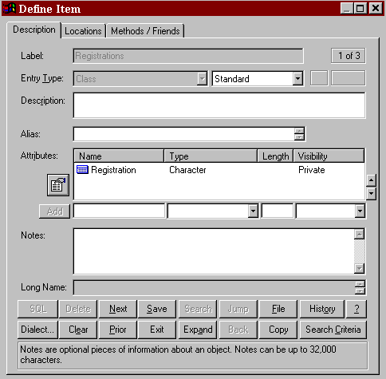Figure 17-3 Class Attributes

Methods
Methods (or Member Functions) are the operations that are defined for accessing a class. The Methods field contains a list of the functions for a class showing the name, return value, argument list, and flags to indicate its visibility. To add, change, or remove methods, click on the Methods field and click the Attributes Details button or select Add/Change from the Repository Object menu. To add a new method for a class, click the New button and type the name of method you wish to add. To search for methods that have already been defined in the repository, click the Search button. The list contains all modules that have previously been defined in the repository. If the module already belongs to a class, the class name is displayed. Note that when you select a module that already exists, the complete definition for that module is used including return value and argument list. Click OK to add the method name to the list of methods for the current class. For each method, the following information can be defined:

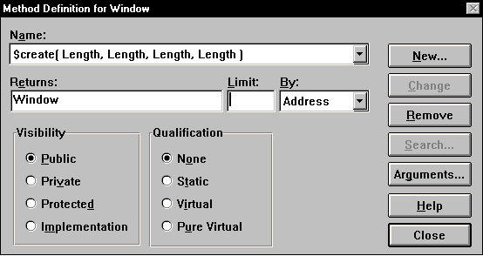Figure 17-4 Class Methods

- Returns. The return type can be a class or data element. If the type does not exist in the repository, a new class is created. The Location field of the attribute type contains a reference to the method. This is an optional field. Click the Search button to display a list of valid types.
- Limit. The number or size of the parameter. If this field is blank, it occurs once.
- By. A qualifier to indicate how the return value is passed. Value indicates a copy of the parameter is passed; Address indicates a pointer to the object is to be used; and Reference indicates a reference to an object is to be used.
- Visibility. Public methods have global visibility. Private methods are only accessible to other member functions within the same class and friends. Protected methods are accessible to derived classes and friends. Implementation methods are only accessible to the class itself. The default is Public.
- Qualification. Static indicates a method can be used without a specific instance of an object (it can only be used with static attributes (data members)). A Virtual method is one that you expect to be redefined in a derived class. A Pure Virtual method has no definition and must be defined in a derived class. A class with any pure virtual functions is an abstract (or virtual) class. The default is None.
- Arguments. A list of parameters to be used by the method. This is an optional field. If a method appears more than once with the same name within a class, it must have a different argument list for each definition. This is known as function overloading. See the next section for defining arguments.

When a method is added to a class definition, an entry of type module is created in the repository. The long name includes the class name and the argument list. The argument list is needed to differentiate between overloaded functions.

Note
 Because the same name can be used for more than one method, there may be duplicate module entries in the repository, each belonging to a different class.

Arguments for Methods
When defining methods (member functions) for a class, the parameters to the function need to be specified. To add, change, or remove arguments, click the Arguments button on the Method Definition dialog box. For each argument, the following can be defined:
  - Name. The name of the parameter. This is an optional field.
  - Type. The parameter type can be a class or data element. If the type does not exist in the repository, a new class is created. This is a mandatory field. The Search button can be used to display a list of valid types. If the parameter type is a data element or elemental class, its physical characteristics are displayed.
  - Limit. The number or size of the parameter. If this field is blank, it occurs once.
  - Pass By. A qualifier to indicate the how the parameter is passed. Value indicates a copy of the parameter is passed; Address indicates a pointer to the object is to be used; and Reference indicates a reference to an object is to be used. The default is Value.
  - Qualification. Constant indicates a parameter‘s value cannot be changed. Volatile indicates the parameter can be modified by something other than the program, either the operating system or hardware. The default is None.
  - Physical Characteristics. If the parameter type is elemental, the physical characteristics can be set.

For every item entered into the Type field, Visible Analyst creates a repository entry (if one with the same name does not already exist). These repository entries are generally created as classes unless a data element already exists with the same name or the physical characteristics are defined.

As you enter items, the dialog box automatically scrolls as necessary to allow you to enter more items until you have finished. INSERT is used to insert a new parameter into the list at the current position, while the DELETE key removes the current parameter (the current position is indicated by ➢➢). When you have completed the entries, click OK to update the method name field. Item names entered into this field may contain up to 128 characters each and may consist of any upper or lower case letters, numbers, spaces, periods, underscore characters and hyphens; but the first character must always be a letter.

Friends
The Friends field displays a list of both friend classes and methods (or functions). A friend is allowed access to the private data members of a class. To add friends, click on the Friends field and click the Search button, select Add from the Repository Object menu, or double- click on the Friends field while pressing CTRL key. A list of classes and member functions is displayed in the Search list box. Locate each repository item you want to place in the Friends field and click the Search button; the item is added to the Select list box at the bottom. When you have found all of the entries you want, click the Select button and they are entered into the Friends field.

To remove a friend, highlight the desired item and press the DELETE key or select Cut or Delete from the Repository Object menu.

Navigation Capabilities
In this section, you change the displayed repository entry using Next, Prior, and Jump.

Note
 The repository saves some internal settings for the duration of a Visible Analyst session. If these are set incorrectly, they may interfere with the smooth flow of this lesson. Therefore, we suggest that if you or another user worked in the repository during the current session, you should exit to Windows and restart Visible Analyst. In this way, you have a clean slate on which to run this lesson.

Open the Repository: | 1 | Access the repository using either Define from the Repository menu or CTRL+D. A blank Define dialog box is displayed.
Access an Entry: | 2 | Type ―Person Information‖ in the Label field and press ENTER twice. (Pressing ENTER once brings up the Search dialog box. Pressing it a second time displays the entry found. If you press ENTER twice quickly, you get the same result without displaying the search box.) The repository entry for Person Information displays with all of the information that has been entered into the repository for this entry.
Move Around: | 3 | Click Next. The next entry in alphabetical order is displayed.
 | 4 | Click Prior. Person Information is again displayed.

Jump to Other Entries: | 5 | Click the element Name in the Attributes field. (It may be necessary to scroll the contents of the field to bring Name into view.) Click Jump. (Click Yes if you are asked if you want to save Person Information.) The repository entry for the data element Name is displayed.
 | 6 | Move to page two by clicking the Physical Information tab at the top of the dialog box. (The current page number is displayed in the upper right corner of the Define window.) This displays more information about the current entry, including the Location information that indicates where the current entry is used.
 | 7 | Click the line in the Location field containing Person Information. This highlights the line.
 | 8 | Click Jump. The entry for Person Information is once again displayed. The Locations tab (page 2) is currently displayed. An alternative to selecting Jump to switch to another repository entry is to double-click the entry name in the Location field or to click the Back button.
 | 9 | Move to page one by clicking the Description tab.

Search Capabilities
Searching for entries in the repository is an easy procedure. It can also be a very useful feature because you can set the Search Criteria to display only certain entry types as you move from one repository entry to the next. To search for an entry in the repository:

Access an Entry: | 1 | Click Clear. This clears the dialog box but does not delete the entry.
 | 2 | Type ―Road Test‖ and press ENTER twice. The repository entry for Road Test is displayed with all of the information that has been entered into the repository for this entry. (This was done for you in the samples included with the TEST project.)
 | 3 | Click Clear.

Search for the | 4 | Click the Search button to open the search box to select
Entry: |  | from the repository. Type ―r‖ and entries that begin with
 |  | ―r‖ appear in the list box. If you now type an ―o,‖ you see
 |  | that the repository searches incrementally as you type,
 |  | getting closer to the entry you want.

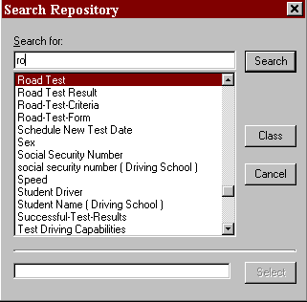Figure 17-5 Repository Search Dialog Box

5 Click Road Test and then click Search. The repository entry for Road Test is displayed.

Setting the Search Criteria
Search criteria set the scope of the entries that are displayed as you search through the repository.

Clear the Dialog Box: | 1 | Click Clear to clear the dialog box.
Set the Criteria: | 2 | Click Search Criteria. You see a dialog box  entitled Set Search Criteria, as shown in Figure 17-6.

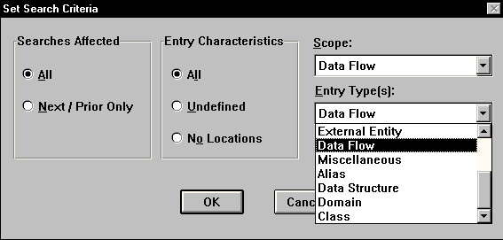Figure 17-6 Setting Repository Search Criteria

- In the box entitled Searches Affected, select All. This is the method used to limit the scope of the entries displayed when navigating the repository using Next and Prior, as well as the entries that are displayed when you select Search.

- In the box labeled Entry Characteristics, select All. This tells Visible Analyst to search all items in the repository, rather than only those entries that are Undefined or entries that have No Locations. No Location entries are typically those that have been entered directly into the repository rather than added to the repository by being placed on a diagram.

- Click the down arrow on the right side of the field marked Scope. This allows you to choose the diagram type to which you wish to limit your search. Select Data Flow.

- Click the down arrow on the right side of the field marked Entry Type(s). This allows you to be very specific about the type of entry to which you wish to limit your search. You can choose individual types and some combination types.

- Select Data Flow, then click OK.

Try Out the Criteria: | 8 | At the blank Define dialog box, click Search. Because your search criteria limits searches to data flows, the list displays only the entries in the repository of the type data flow. Select Road-Test-Criteria and then click Search.
 | 9 | Now click Next. The next entry displayed is the next data flow in alphabetical order, rather than simply the next entry in alphabetical order. If you click Next a few more times, you notice that only data flow entries are displayed.
 | 10 | Click Search Criteria again and set Scope back to Entire Repository. Be sure that Entry Type(s) is set to All.  Click OK.

Using Search to Add Items to a Field
The Search feature can also be used to add repository entries to a field without retyping them. This option is very useful for adding multiple data elements to an Attributes field. Instead of typing the name into the field, you can select it using the Search function.

Clear the Dialog Box: | 1 | Click Clear.
Find an Entry: | 2 | Type ―V‖ in the Label field and click Search.  Valid-Applicant should be the first entry on the list. Click on it and it appears in the Search For field. Click Search and the repository entry for Valid-Applicant appears.
Select Attributes: | 3 | Click on the Attributes field.
 | 4 | Click the Search button. The available data elements are displayed. Double-click on Address, Birth Date, Name, and Social Security Number. All the selected elements are displayed at the bottom of the Search dialog box as shown in Figure 17-7.

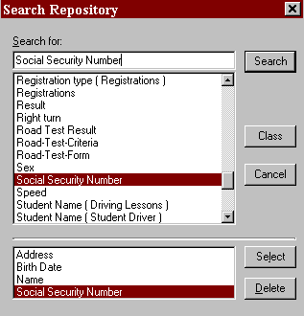Figure 17-7 Add Information with Search

Add Attributes | 5 | Click Select. All the selected elements are added to the
and Save: |  | Attributes field. Click Save and then click Exit.

Where To Go from Here

OVERVIEW
This concludes the Visible Analyst tutorial. To exit the program, select Exit from the File
menu.

You have now completed exercises in many of the major elements of planning, structured analysis and design, data modeling and object modeling:
- Drawing diagrams to model a system.
- Using methodology rules to insure against inconsistencies.
- Adding written definition to the graphic model.
- Embellishing the model following the initial layout.
- Expanding the model through definition of repository elements.
- Generating reports.

All structured software and systems engineering involve these same basic operations.

REAL WORLD APPLICATION
The example project that you created was a simple one. The real power of MDA is in the application to systems too complex to keep in your head at one time, too large to be reviewed by inspection, too widespread to have only one person working on the whole job. These types of projects include nearly every system designed today. That power shows itself in four areas:
- The assurance of accuracy and completeness, that no elements are left dangling or unaccounted for.
- The prompting and reminders that error checks and repository output provide, to focus attention in the midst of a dauntingly complex assignment.
- The word processing-like ease with which changes and modifications can be accomplished, while ripple effects are flagged and accounted for.
- The convenience of thorough documentation that is produced concurrently with the design, not as a drudgery-filled after-effort.

The power of MDA further multiplies into substantial gains in productivity, communication and quality when applied to team effort. The Corporate and Zachman Editions of Visible Analyst have significant capabilities for exporting and importing information, either through portable media or through participation in a local area network. This allows Visible Analyst to become an integral part of any development environment, sharing information and expanding the value of labor. Many groups thus can benefit from another group‘s hard work.

Finally, the application of the power of MDA productivity enhancement is not limited to software but can be applied toward analyzing and designing any system, such as:

Manufacturing | Medical Diagnostic Analysis
Planning | Command and Control Operations
Processing | Administrative Procedures
Legal/Judicial | Inventory Control
Audits

Visible Analyst is designed to be a natural extension of the way you think, create, and analyze. Our goal is to ―Put MDA Within Everybody‘s Reach‖ and to make MDA tools and the methodologies of structured analysis, design, data modeling and object modeling a natural, seamless, integrated part of your everyday work, rather than an arcane ritual to be occasionally endured by specialists. The integration and flexibility to use the components and elements that you deem necessary for your application provide you with a customizable tool set that can be adapted to support how you choose to work on the design and development of information systems.

WHAT TO DO NEXT?
There are still many things for you to do to become comfortable and committed to the use of a MDA tool. We suggest the following:
  - Study and review the logic concepts introduced in the tutorial (consider reviewing the referenced materials).
  - Review the tutorial steps and practice any areas that were unclear.
  - Select a personal real-world project to do using Visible Analyst. Make it a modest-sized effort to give you some time to explore and experiment with the tool.
  - Select the parts and components that you want to use in your software development practice.
  - Practice, practice, practice. Make adjustments where needed.
  - Make the tool a regular part of all of your projects.
  - Define standards and procedures for library components.
  - Build disciplines and skills with concepts and Visible Analyst.
  - Use technical support as needed - don‘t get stuck, don‘t become frustrated.

- Stop and evaluate what you have done, show others, review the work of others - find ways to improve the content and the processes.
- Practice reusability wherever possible.
- Stay up to date with the tool and the evolving methodologies.
- Build a library of materials for use in future projects.

CONCLUSION
We hope that these lessons have helped to make you feel comfortable with the planning, structured systems analysis and design, and data modeling tools, and their implementations in our product.

For more information or if you have any questions about MDA or structured analysis, please contact the Visible Systems technical support staff:

Telephone (617) 902-0767
FAX (508) 302-2400
Internet: http://www.visiblesystemscorp.com
E-mail: support@visiblesystemscorp.com

You can send your comments to:

Customer Comments Visible Systems Corporation
24 School Street, 2nd floor
Boston, MA 02108

